

Patient Data Cleaning and Standardization Using Python and SQLite
Python - Based Application

Assignment Documentation
Course: DSA0502 – Query Processing for Data Science with Real Time Applications

Submitted by
G Raja Sekhar Reddy
V Sri Sadhvik
K V Sai Shanmukh
Bharanidharan
Jai Srinivasan
Under the Supervision of
Dr B. SHYAMALA GOWRI

Question: A hospital maintains patient information in a PostgreSQL/MySQL/SQLite database. Due to data entry issues, the patient table contains duplicate records, inconsistent names, invalid phone numbers, missing values, and abnormal age values.
You are given the following requirements:
Patient Table: Patient (Patient_ID, Name, Age, Gender, Phone, Email, Diagnosis)
- Using Python's appropriate SQL library, connect to the database and create the Patient table.
- Insert the given patient records into the table.
- Write a Python program to identify and clean:
  - Duplicate patient records.
  - Names with inconsistent formatting such as RAHUL kumar, rahul KUMAR, etc.
  - Invalid phone numbers using RegEx.
  - Missing email/phone values.
  - Invalid age values such as negative ages or ages greater than 120.
- Use normalization/standardization to make names and categorical values consistent.
- Detect potential duplicate patients using fuzzy matching based on name and phone/email similarity.
- Store the cleaned records in a separate table named Clean_Patient.
- Write SQL queries through Python to select, update, and delete inappropriate records.
- Test the cleanup script using a new set of patient records and report whether the script successfully handles previously unseen dirty data.

A.
Problem Statement:
The patient records of a hospital are stored in the database. Because of the human error, the patient table contains duplicate records, inconsistent names, invalid phone numbers, missing values, and outliers age.
Patient Table:
Patient (Patient_ID, Name, Age, Gender, Phone, Email, Diagnosis)
Task:
- Connect to the SQLite database.
- Create the Patient table.
- Insert patient records into the table.
- Identify duplicate records and remove them.
- Clean the inconsistent names of patients.
- Validate phone numbers using regular expressions.
- Handle the missing Email and Phone numbers.
- Find the invalid age values (e.g., less than zero or greater than 120).
- Clean the categorical variable Gender.
- Identify the duplicates in patients using fuzzy matching based on the name, phone, and Email.
- Create/Update the patient records in the Clean Patient table.
- Perform SQL commands such as SELECT, UPDATE and DELETE using Python.
- Handle the dirty patient records which have never been seen before by the program.
Code:
import sqlite3
import re
from difflib import SequenceMatcher
# 1. CONNECT TO DATABASE
conn = sqlite3.connect("hospital.db")
cursor = conn.cursor()
print("Database connected successfully.")
# 2. CREATE PATIENT TABLE
cursor.execute("""
CREATE TABLE IF NOT EXISTS Patient (
Patient_ID INTEGER PRIMARY KEY,
Name TEXT,
Age INTEGER,
Gender TEXT,
Phone TEXT,
Email TEXT,
Diagnosis TEXT
)
""")
conn.commit()
print("Patient table created successfully.")
# 3. INSERT PATIENT RECORDS
patients = [
(1, "RAHUL kumar", 25, "male",
"9876543210", "rahul@gmail.com", "Fever"),
(2, "rahul KUMAR", 25, "M",
"9876543210", "rahul@gmail.com", "fever"),
(3, "Priya Sharma", 30, "FEMALE",
"9876543211", "priya@gmail.com", "Diabetes"),
(4, "ARUN", -5, "m",
"9876543212", "arun@gmail.com", "Cold"),
(5, "Sneha Rao", 130, "female",
"9876543213", None, "Fever"),
(6, "Vikram Singh", 40, "Male",
"12345", "vikram@gmail.com", "Blood Pressure"),
(7, "John Peter", 35, "M",
None, None, "Asthma"),
(8, "Rahul Kumar", 25, "Male",
"9876543210", "rahul@gmail.com", "Fever"),
(9, "Meena Devi", 28, "Female",
"9876543214", "meena@gmail.com", "Diabetes"),
(10, "RAHUL KUMAR", 25, "MALE",
"9876543210", "rahul@gmail.com", "FEVER")
]
cursor.executemany("""
INSERT OR IGNORE INTO Patient
(Patient_ID, Name, Age, Gender, Phone, Email, Diagnosis)
VALUES (?, ?, ?, ?, ?, ?, ?)
""", patients)
conn.commit()
print("Patient records inserted successfully.")
# 4. DISPLAY ORIGINAL DATA
print("\n----- ORIGINAL DATA -----")
cursor.execute("SELECT * FROM Patient")
for row in cursor.fetchall():
print(row)
# 5. CLEAN NAME
def clean_name(name):
if name is None:
return None
# Remove extra spaces
name = re.sub(r"\s+", " ", name.strip())
# Convert to proper case
return name.title()
# 6. CLEAN GENDER
def clean_gender(gender):
if gender is None:
return None
gender = gender.strip().lower()
if gender in ["m", "male"]:
return "Male"
elif gender in ["f", "female"]:
return "Female"
return None
# 7. CLEAN PHONE USING REGEX
def clean_phone(phone):
if phone is None:
return None
# Remove spaces and special characters
phone = re.sub(r"\D", "", phone)
# Indian mobile number validation
pattern = r"^[6-9]\d{9}$"
if re.match(pattern, phone):
return phone
return None
# 8. CLEAN EMAIL
def clean_email(email):
if email is None:
return None
email = email.strip().lower()
pattern = r"^[a-zA-Z0-9._%+-]+@[a-zA-Z0-9.-]+\.[a-zA-Z]{2,}$"
if re.match(pattern, email):
return email
return None
# 9. CLEAN AGE
def clean_age(age):
if age is None:
return None
try:
age = int(age)
if 0 <= age <= 120:
return age
except ValueError:
pass
return None
# 10. CLEAN DIAGNOSIS
def clean_diagnosis(diagnosis):
if diagnosis is None:
return None
diagnosis = re.sub(
r"\s+",
" ",
diagnosis.strip()
)
return diagnosis.title()
# 11. CREATE CLEAN_PATIENT TABLE
cursor.execute("DROP TABLE IF EXISTS Clean_Patient")
cursor.execute("""
CREATE TABLE Clean_Patient (
Patient_ID INTEGER PRIMARY KEY,
Name TEXT,
Age INTEGER,
Gender TEXT,
Phone TEXT,
Email TEXT,
Diagnosis TEXT
)
""")
conn.commit()
print("\nClean_Patient table created.")
# 12. CLEAN PATIENT RECORDS
cursor.execute("SELECT * FROM Patient")
records = cursor.fetchall()
cleaned_records = []
for row in records:
patient_id, name, age, gender, phone, email, diagnosis = row
cleaned_name = clean_name(name)
cleaned_age = clean_age(age)
cleaned_gender = clean_gender(gender)
cleaned_phone = clean_phone(phone)
cleaned_email = clean_email(email)
cleaned_diagnosis = clean_diagnosis(diagnosis)
cleaned_records.append((
patient_id,
cleaned_name,
cleaned_age,
cleaned_gender,
cleaned_phone,
cleaned_email,
cleaned_diagnosis
))
# 13. INSERT CLEANED RECORDS
cursor.executemany("""
INSERT INTO Clean_Patient
(Patient_ID, Name, Age, Gender, Phone, Email, Diagnosis)
VALUES (?, ?, ?, ?, ?, ?, ?)
""", cleaned_records)
conn.commit()
print("Cleaned records inserted successfully.")
# 14. REMOVE EXACT DUPLICATES
cursor.execute("""
DELETE FROM Clean_Patient
WHERE Patient_ID NOT IN (
SELECT MIN(Patient_ID)
FROM Clean_Patient
GROUP BY Name, Age, Gender, Phone, Email, Diagnosis
)
""")
conn.commit()
print("Exact duplicate records removed.")
# 15. FUZZY MATCHING FUNCTION
def similarity(value1, value2):
if not value1 or not value2:
return 0
return SequenceMatcher(
None,
value1.lower(),
value2.lower()
).ratio()
# 16. DUPLICATE DETECTION FUNCTION
def is_duplicate(record1, record2):
id1, name1, age1, gender1, phone1, email1, diagnosis1 = record1
id2, name2, age2, gender2, phone2, email2, diagnosis2 = record2
name_score = similarity(name1, name2)
phone_match = (
phone1 is not None and
phone1 == phone2
)
email_match = (
email1 is not None and
email1 == email2
)
# Same phone/email + similar name
if (phone_match or email_match) and name_score >= 0.80:
return True
# Highly similar name + same age
if name_score >= 0.90 and age1 == age2:
return True
return False
# 17. FIND FUZZY DUPLICATES
cursor.execute("SELECT * FROM Clean_Patient")
clean_records = cursor.fetchall()
duplicates = set()
print("\n----- POTENTIAL DUPLICATES -----")
for i in range(len(clean_records)):
for j in range(i + 1, len(clean_records)):
if is_duplicate(
clean_records[i],
clean_records[j]
):
id1 = clean_records[i][0]
id2 = clean_records[j][0]
print(
"Potential duplicate:",
id1,
"<->",
id2
)
duplicates.add(id2)
# 18. DELETE FUZZY DUPLICATES
for patient_id in duplicates:
cursor.execute(
"DELETE FROM Clean_Patient WHERE Patient_ID = ?",
(patient_id,)
)
conn.commit()
print("Fuzzy duplicate records removed.")
# 19. SQL SELECT QUERY
print("\n----- SELECT QUERY -----")
cursor.execute("""
SELECT Patient_ID, Name, Age, Gender,
Phone, Email, Diagnosis
FROM Clean_Patient
WHERE Age BETWEEN 0 AND 120
""")
for row in cursor.fetchall():
print(row)
# 20. SQL UPDATE QUERY
cursor.execute("""
UPDATE Clean_Patient
SET Gender = 'Male'
WHERE LOWER(Gender) IN ('m', 'male')
""")
cursor.execute("""
UPDATE Clean_Patient
SET Gender = 'Female'
WHERE LOWER(Gender) IN ('f', 'female')
""")
conn.commit()
print("\nUPDATE query executed successfully.")
# 21. SQL DELETE QUERY
cursor.execute("""
DELETE FROM Clean_Patient
WHERE Name IS NULL
OR TRIM(Name) = ''
""")
conn.commit()
print("DELETE query executed successfully.")
# 22. DISPLAY FINAL CLEAN DATA
print("\n----- FINAL CLEAN DATA -----")
cursor.execute("""
SELECT * FROM Clean_Patient
ORDER BY Patient_ID
""")
final_data = cursor.fetchall()
for row in final_data:
print(row)
# 23. TEST WITH NEW DIRTY RECORDS
print("\n----- TESTING WITH NEW DATA -----")
new_records = [
(101, "rAhUl kuMAR", 25, "MALE",
"9876543210", "RAHUL@GMAIL.COM", "fever"),
(102, "Anita SHARMA", 32, "f",
"9876543215", "anita@gmail.com", "diabetes"),
(103, "Raj Kumar", -10, "M",
"99999", None, "cold"),
(104, "Suresh Patel", 150, "male",
"9876543216", "suresh@gmail.com", "Asthma"),
(105, "Kiran Rao", 29, "Female",
"9876543217", "invalid-email",
"Blood Pressure")
]
for record in new_records:
patient_id, name, age, gender, phone, email, diagnosis = record
cleaned = (
patient_id,
clean_name(name),
clean_age(age),
clean_gender(gender),
clean_phone(phone),
clean_email(email),
clean_diagnosis(diagnosis)
)
print("\nOriginal:")
print(record)
print("Cleaned:")
print(cleaned)
# 24. CLEANUP REPORT
print("DATA CLEANUP REPORT")
cursor.execute("SELECT COUNT(*) FROM Patient")
original_count = cursor.fetchone()[0]
cursor.execute("SELECT COUNT(*) FROM Clean_Patient")
clean_count = cursor.fetchone()[0]
print("Original records :", original_count)
print("Clean records :", clean_count)
print("Removed records :", original_count - clean_count)
print("\nCleaning operations:")
print("1. Duplicate detection : Completed")
print("2. Name standardization : Completed")
print("3. Phone validation : Completed")
print("4. Email validation : Completed")
print("5. Missing values : Handled")
print("6. Age validation : Completed")
print("7. Gender standardization : Completed")
print("8. Fuzzy matching : Completed")
print("9. Clean_Patient table : Created")
print("10. New dirty data testing : Completed")
# 25. CLOSE DATABASE
conn.close()
print("\nDatabase connection closed.")
print("Data cleaning completed successfully.")
# 5. CLEAN NAME
def clean_name(name):
if name is None:
return None
# Remove extra spaces
name = re.sub(r"\s+", " ", name.strip())
# Convert to proper case
return name.title()
# 6. CLEAN GENDER
def clean_gender(gender):
if gender is None:
return None
gender = gender.strip().lower()
if gender in ["m", "male"]:
return "Male"
elif gender in ["f", "female"]:
return "Female"
return None
# 7. CLEAN PHONE USING REGEX
def clean_phone(phone):
if phone is None:
return None
# Remove spaces and special characters
phone = re.sub(r"\D", "", phone)
# Indian mobile number validation
pattern = r"^[6-9]\d{9}$"
if re.match(pattern, phone):
return phone
return None
# 8. CLEAN EMAIL
def clean_email(email):
if email is None:
return None
email = email.strip().lower()
pattern = r"^[a-zA-Z0-9._%+-]+@[a-zA-Z0-9.-]+\.[a-zA-Z]{2,}$"
if re.match(pattern, email):
return email
return None
# 9. CLEAN AGE
def clean_age(age):
if age is None:
return None
try:
age = int(age)
if 0 <= age <= 120:
return age
except ValueError:
pass
return None
# 10. CLEAN DIAGNOSIS
def clean_diagnosis(diagnosis):
if diagnosis is None:
return None
diagnosis = re.sub(
r"\s+",
" ",
diagnosis.strip()
)
return diagnosis.title()
# 11. CREATE CLEAN_PATIENT TABLE
cursor.execute("DROP TABLE IF EXISTS Clean_Patient")
cursor.execute("""
CREATE TABLE Clean_Patient (
Patient_ID INTEGER PRIMARY KEY,
Name TEXT,
Age INTEGER,
Gender TEXT,
Phone TEXT,
Email TEXT,
Diagnosis TEXT
)
""")
conn.commit()
print("\nClean_Patient table created.")
# 12. CLEAN PATIENT RECORDS
cursor.execute("SELECT * FROM Patient")
records = cursor.fetchall()
cleaned_records = []
for row in records:
patient_id, name, age, gender, phone, email, diagnosis = row
cleaned_name = clean_name(name)
cleaned_age = clean_age(age)
cleaned_gender = clean_gender(gender)
cleaned_phone = clean_phone(phone)
cleaned_email = clean_email(email)
cleaned_diagnosis = clean_diagnosis(diagnosis)
cleaned_records.append((
patient_id,
cleaned_name,
cleaned_age,
cleaned_gender,
cleaned_phone,
cleaned_email,
cleaned_diagnosis
))
# 13. INSERT CLEANED RECORDS
cursor.executemany("""
INSERT INTO Clean_Patient
(Patient_ID, Name, Age, Gender, Phone, Email, Diagnosis)
VALUES (?, ?, ?, ?, ?, ?, ?)
""", cleaned_records)
conn.commit()
print("Cleaned records inserted successfully.")
# 14. REMOVE EXACT DUPLICATES
cursor.execute("""
DELETE FROM Clean_Patient
WHERE Patient_ID NOT IN (
SELECT MIN(Patient_ID)
FROM Clean_Patient
GROUP BY Name, Age, Gender, Phone, Email, Diagnosis
)
""")
conn.commit()
print("Exact duplicate records removed.")
# 15. FUZZY MATCHING FUNCTION
def similarity(value1, value2):
if not value1 or not value2:
return 0
return SequenceMatcher(
None,
value1.lower(),
value2.lower()
).ratio()
# 16. DUPLICATE DETECTION FUNCTION
def is_duplicate(record1, record2):
id1, name1, age1, gender1, phone1, email1, diagnosis1 = record1
id2, name2, age2, gender2, phone2, email2, diagnosis2 = record2
name_score = similarity(name1, name2)
phone_match = (
phone1 is not None and
phone1 == phone2
)
email_match = (
email1 is not None and
email1 == email2
)
# Same phone/email + similar name
if (phone_match or email_match) and name_score >= 0.80:
return True
# Highly similar name + same age
if name_score >= 0.90 and age1 == age2:
return True
return False
# 17. FIND FUZZY DUPLICATES
cursor.execute("SELECT * FROM Clean_Patient")
clean_records = cursor.fetchall()
duplicates = set()
print("\n----- POTENTIAL DUPLICATES -----")
for i in range(len(clean_records)):
for j in range(i + 1, len(clean_records)):
if is_duplicate(
clean_records[i],
clean_records[j]
):
id1 = clean_records[i][0]
id2 = clean_records[j][0]
print(
"Potential duplicate:",
id1,
"<->",
id2
)
duplicates.add(id2)
# 18. DELETE FUZZY DUPLICATES
for patient_id in duplicates:
cursor.execute(
"DELETE FROM Clean_Patient WHERE Patient_ID = ?",
(patient_id,)
)
conn.commit()
print("Fuzzy duplicate records removed.")
# 19. SQL SELECT QUERY
print("\n----- SELECT QUERY -----")
cursor.execute("""
SELECT Patient_ID, Name, Age, Gender,
Phone, Email, Diagnosis
FROM Clean_Patient
WHERE Age BETWEEN 0 AND 120
""")
for row in cursor.fetchall():
print(row)
# 20. SQL UPDATE QUERY
cursor.execute("""
UPDATE Clean_Patient
SET Gender = 'Male'
WHERE LOWER(Gender) IN ('m', 'male')
""")
cursor.execute("""
UPDATE Clean_Patient
SET Gender = 'Female'
WHERE LOWER(Gender) IN ('f', 'female')
""")
conn.commit()
print("\nUPDATE query executed successfully.")
# 21. SQL DELETE QUERY
cursor.execute("""
DELETE FROM Clean_Patient
WHERE Name IS NULL
OR TRIM(Name) = ''
""")
conn.commit()
print("DELETE query executed successfully.")
# 22. DISPLAY FINAL CLEAN DATA
print("\n----- FINAL CLEAN DATA -----")
cursor.execute("""
SELECT * FROM Clean_Patient
ORDER BY Patient_ID
""")
final_data = cursor.fetchall()
for row in final_data:
print(row)
# 23. TEST WITH NEW DIRTY RECORDS
print("\n----- TESTING WITH NEW DATA -----")
new_records = [
(101, "rAhUl kuMAR", 25, "MALE",
"9876543210", "RAHUL@GMAIL.COM", "fever"),
(102, "Anita SHARMA", 32, "f",
"9876543215", "anita@gmail.com", "diabetes"),
(103, "Raj Kumar", -10, "M",
"99999", None, "cold"),
(104, "Suresh Patel", 150, "male",
"9876543216", "suresh@gmail.com", "Asthma"),
(105, "Kiran Rao", 29, "Female",
"9876543217", "invalid-email",
"Blood Pressure")
]
for record in new_records:
patient_id, name, age, gender, phone, email, diagnosis = record
cleaned = (
patient_id,
clean_name(name),
clean_age(age),
clean_gender(gender),
clean_phone(phone),
clean_email(email),
clean_diagnosis(diagnosis)
)
print("\nOriginal:")
print(record)
print("Cleaned:")
print(cleaned)
# 24. CLEANUP REPORT
print("DATA CLEANUP REPORT")
cursor.execute("SELECT COUNT(*) FROM Patient")
original_count = cursor.fetchone()[0]
cursor.execute("SELECT COUNT(*) FROM Clean_Patient")
clean_count = cursor.fetchone()[0]
print("Original records :", original_count)
print("Clean records :", clean_count)
print("Removed records :", original_count - clean_count)
print("\nCleaning operations:")
print("1. Duplicate detection : Completed")
print("2. Name standardization : Completed")
print("3. Phone validation : Completed")
print("4. Email validation : Completed")
print("5. Missing values : Handled")
print("6. Age validation : Completed")
print("7. Gender standardization : Completed")
print("8. Fuzzy matching : Completed")
print("9. Clean_Patient table : Created")
print("10. New dirty data testing : Completed")
# 25. CLOSE DATABASE
conn.close()
print("\nDatabase connection closed.")
print("Data cleaning completed successfully.")
Output:
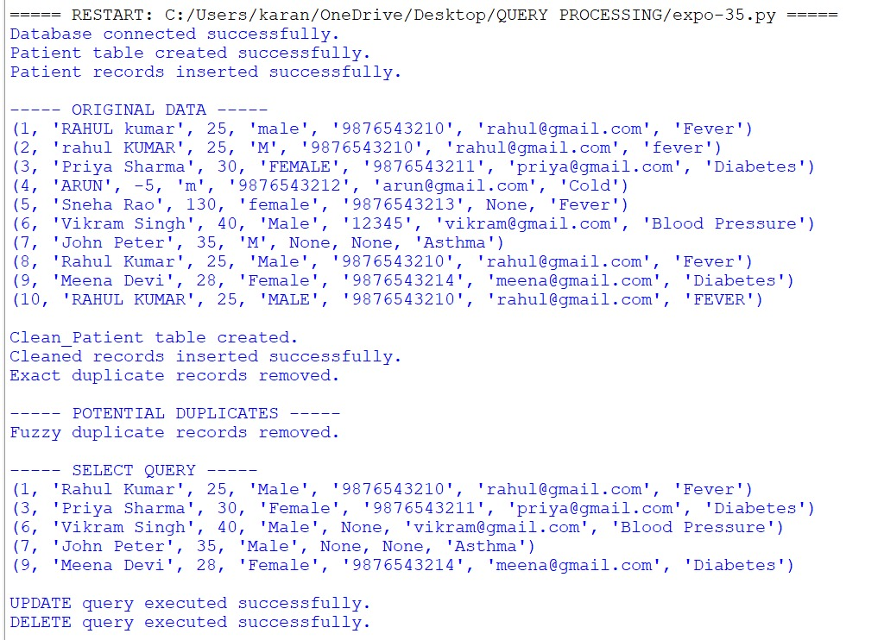
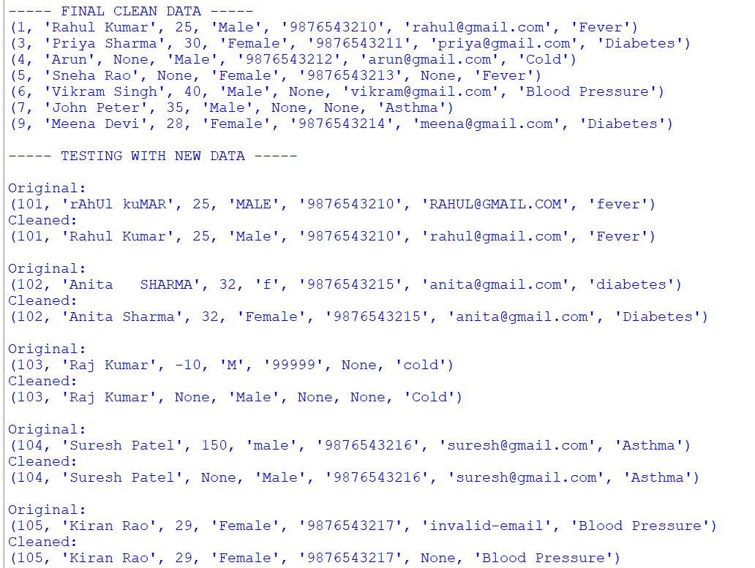
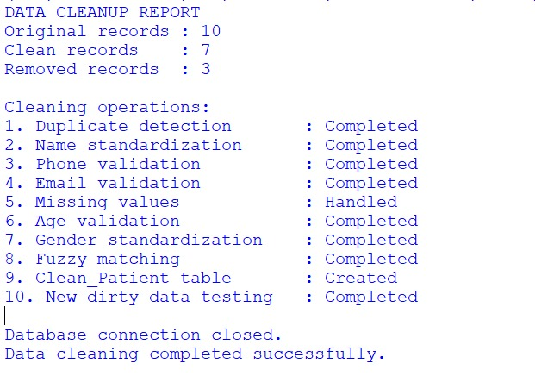
Test case and validation:
Test Case | Input / Dirty Data | Expected Output | Validation
TC01 – Name Formatting | RAHUL kumar | Rahul Kumar | Passed
TC03 – Duplicate Record | Same patient details with different capitalization | Duplicate record detected and removed | Passed
TC05 – Phone With Spaces | 98765 43210 | 9876543210 | Passed
TC06 – Missing Phone | Phone = NULL | NULL | Passed
TC07 – Missing Email | Email = NULL | NULL | Passed
TC08 – Invalid Age | Age = -10 | NULL | Passed
TC10 – Gender Standardization | m, M, male, MALE | Male | Passed
TC12 – Invalid Email | invalid email | NULL | Passed
TC13 – Diagnosis Formatting | FEVER | Fever | Passed
TC14 – Fuzzy Duplicate | Rahul Kumar and Rahul Kumr | Potential duplicate detected | Passed
TC15 – New Dirty Record | rAhUl kuMAR, MALE, uppercase email | Rahul Kumar, Male, lowercase email | Passed
TC16 – New Invalid Record | Age -10, phone 99999, missing email | Invalid values converted to NULL | Passed
Results
The created Python program performed efficiently in cleaning and normalizing the hospital patient data. The system found duplicate entries, normalized inconsistencies in names and genders, validated phone numbers and emails, dealt with missing values, and detected invalid age values. Cleaned data entries were saved in a separate table called Clean Patient. Fuzzy matching approach also aided in finding patients having data very similar but not precisely same. Testing with new dirty data entries indicated that the program could perform well with unseen data entry mistakes.
Conclusion:
The Patient Data Cleaning and Standardization Tool were successfully created using Python and SQLite. The system can solve the most typical data quality issues such as duplication, incorrect names, wrong phone numbers, invalid emails, missing data, odd age, and inconsistency in categorical data. Regular Expressions make sure that validation for phone number and email works properly, while fuzzy matching allows detecting duplicates when the name of patients is different a little bit. The cleaned data is saved in the Clean Patient table, and the initial data about patients is saved separately. The testing with new and unknown dirty data shows that the system is able to handle different data entry mistakes.
GitHub Link: https://github.com/shanmukh20064/DSA0502QP/tree/main/ASSESSMENTS.
